

Fatih Doğaç
CSE344 HW#1 REPORT

1901042654
My program starts with SIGINT handling sigaction.
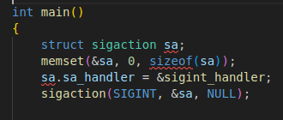

To handle the SIGINT, I kept all the child proccesses id’s in a global pid_t array and I kept the child number too.
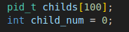

And here is the sigint_handler();
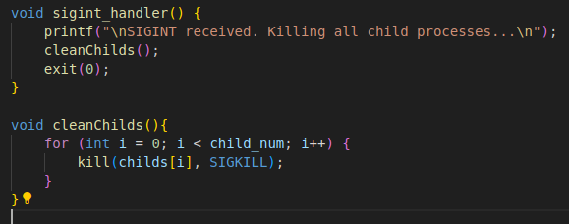
It notifies the user with printf that the SIGINT received and kills all child proccesses than exits.

Then the menu() runs.

Menu function is basically a never ending while loop.

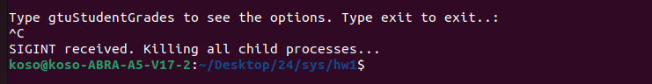
Beginning of the while loop, the program checks if the input is a one word and checks if there is ‘ “ ‘ in the input. And if it is a one word, the program only supports two option: gtuStudentGrades and exit. Other than these two is error.

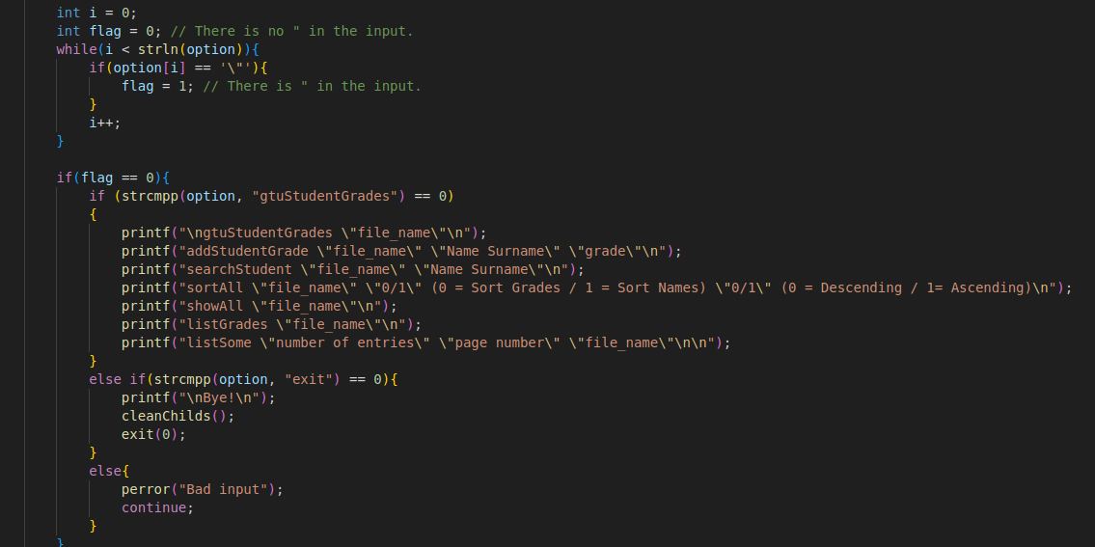
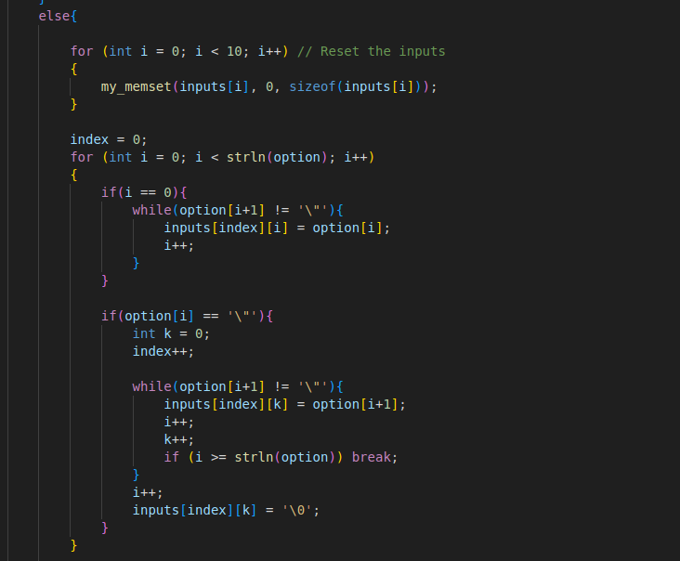
And if it is not a one word input, the program goes into this else.
Memset is for cleaning the inputs array. It prevents the current input to not overlay with old inputs.

Program takes the whole input into option string. And it has a limit of 100 chars.

And then the program checks the option string char by char and if it encounters a quotation mark, it runs until it finds another quotation mark. Stores the word between quotation marks in inputs array.
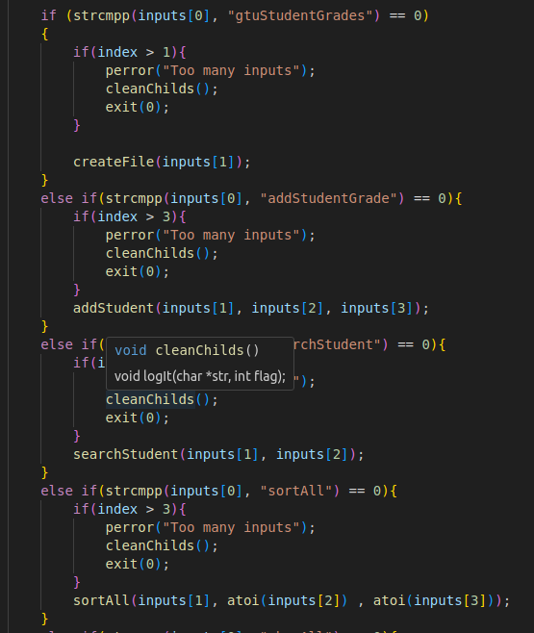

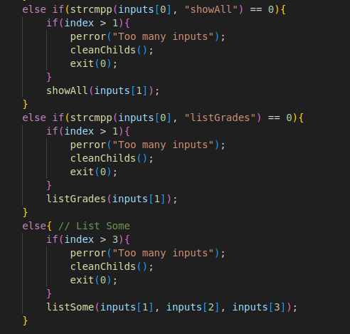

And all the setup is ready. The only matter left is to see what the user wanted to do.

For some reason my strcmpp() didn’t work with “listSome”. I know it is a bad practice but I tried to understand why it works with anything else and not with listSome. Then some time passed and I just gave up and put that command in the else.

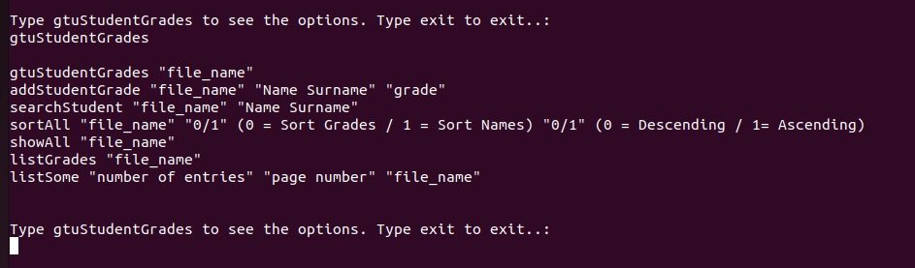
As you can see above, every command has its own function and every one of them checks if the inputs are at the correct number. If not cleans the childs and exits.
1. gtuStudentGrades “grades.txt” command

The program creates a child with fork() and stores the pid of the child and increases the child number. And then it creates the desired file with the proper permissions then lefts. And parent waits for child to finish.

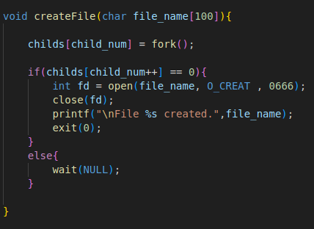

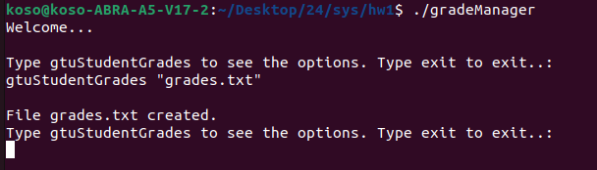

2. addStudentGrade “Name Surname” “AA” command
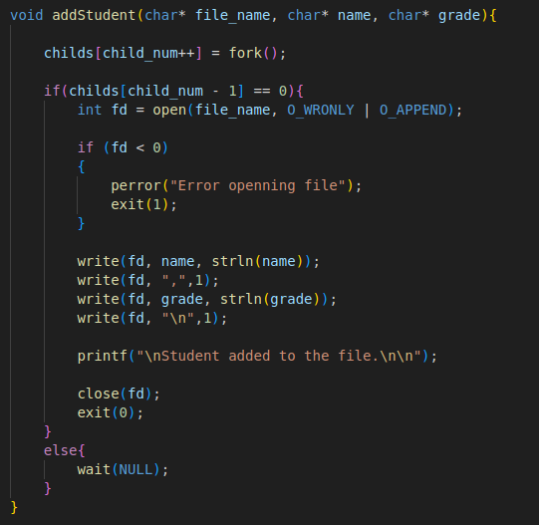
It creates a child and then checks if the file opened successfully. If yes it stores the data in Name Surname,Grade order. And informs the user. Closes the file descriptor and exits. And its parent waits for the child.
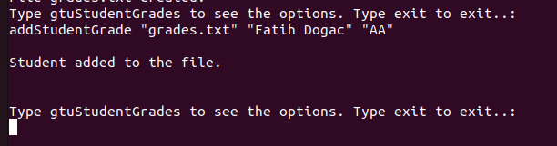
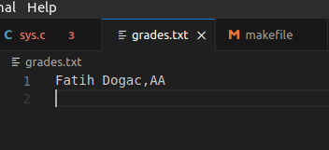

3.searchStudent “Name Surname” command
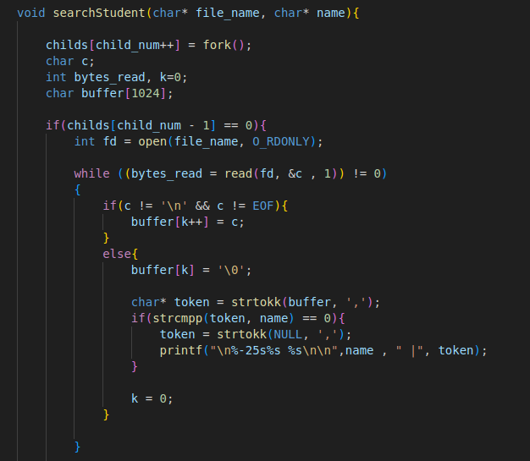
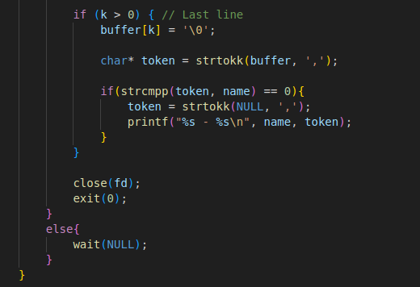

This function reads until it encounters an end of line character or end of file, then it slices the input and compares the name in the current line with the wanted name. If it matches then prints the name and the grade.

The current file:
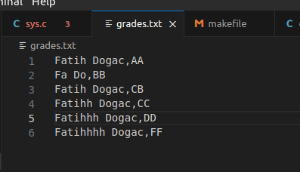

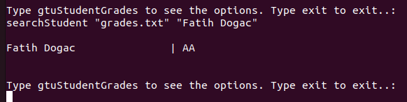

4.sortAll “gradest.txt” “0” “1” command

My sortAll function takes sort order and what to sort as input from user as 0 and 1.

0 stands for Sort Names and 1 for Sort Grades
and the next input 0 stands for Descending order and 1 for Ascending order.

I used bubbleSort for this sorting and put a if in it to sort in ascending or descending order.

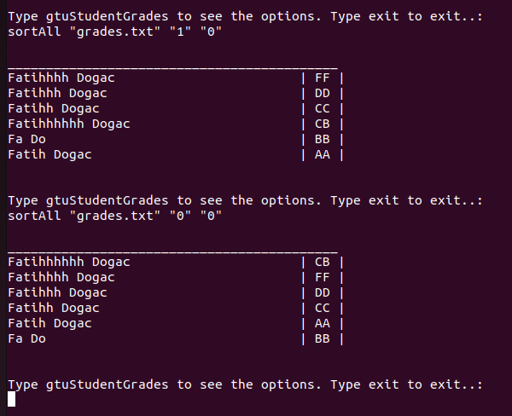

5.Display Commands

I used a printFile() function to avoid code repeatation. I couldn’t do it for other commands because they needed other handling situations.

showAll “grades.txt”
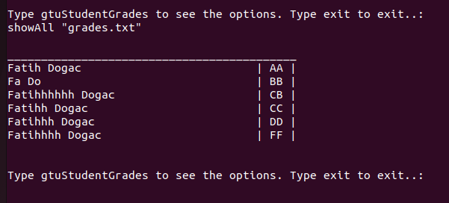
listGrades “grades.txt”
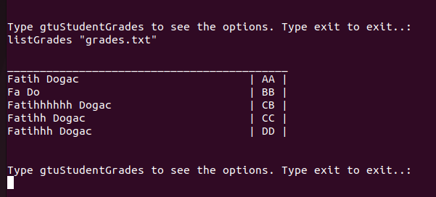
listSome “numofEntries” “pageNumber” “grades.txt”
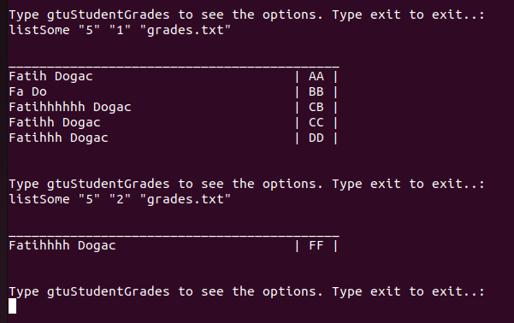
I checked program with gcc -Wall -Wextra and it is okay. Valgrind doesn’t show any leaks. And I tested the program with large files such as 5mb.
I don’t have a logging operation.

This is the makefile:

